GEORGIA STATE UNIVERSITY

Department of Computer Science

CSC 3210 Computer Organization Programming

Lab Section:

Lab 4: Pong on Game Boy Advance

Linh H. Pham

Submitted: November 15, 2024

**Contents**

**1 Introduction**

**2 Apparatus**

**3 Methods**

**4 Results and Discussion**

**5 Conclusions**

**1 Introduction**

* + This lab aims to explore I/O interrupts, simulation, and object-oriented programming on embedded systems.

**2 Apparatus**

* Butano
* C++
* DevkitARM
* GBA Emulators (mGBA)
* Butano guideline

**3 Methods**

**3.1 Task 1**

Setting up DevkitARM to be able to use Butano.

Download and install Butano.

Install mGBA to be able to run the game.

Compile some examples from Butano to make sure the program is working.

**3.2 Task 2**

This task requires creating a Pong game with certain requirements. First, investigate Butano to find the appropriate libraries and functions that are needed for the project. Finding sprites and music from other sources that are still workable in Butano. Generate a background , a paddle, a ball, and some text. Create parameters to make sure the ball will behave based on its location. If the ball hits the top, left, right, or the paddle, it will bounce. If it hits the bottom the game is reset. The score will update its sprites when the ball hits the paddle and reset to 0 when the game reset.

**4 Results and Discussion**

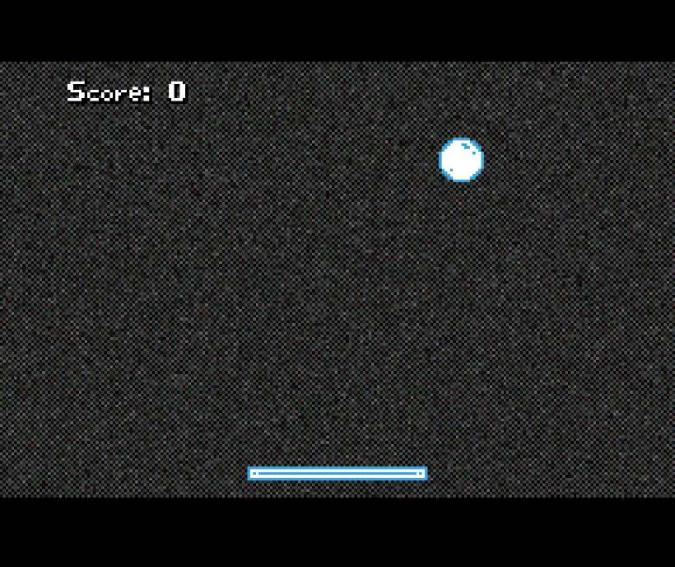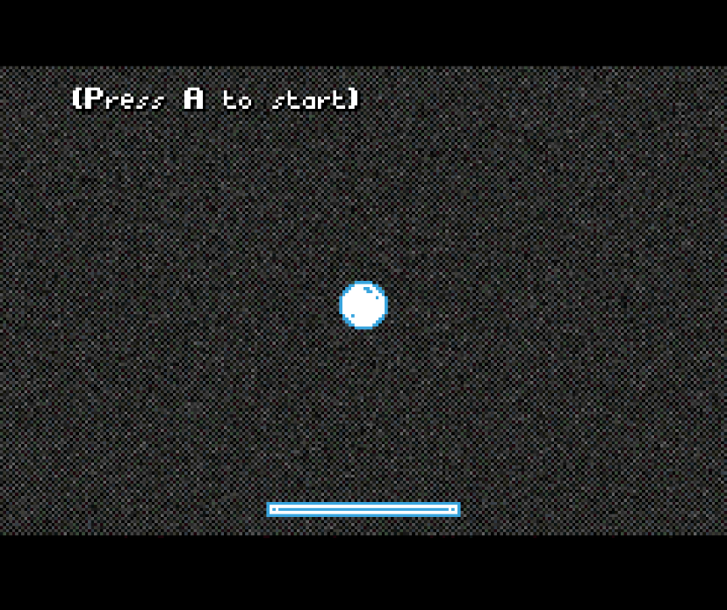After completing the two tasks, the game is in a playable state. The game is run on a simulator to simulate a Gameboy. When pressing a button that represents A on the console, the ball will move in a random direction and bounce when hitting a surface that is not the bottom. Hitting the bottom reset the game. The paddle is controlled by using the left and right arrow. There are limitations on the number of sprites that can be shown on screen. By using object-oriented programming, the game is created by using objects that are available in Butano and other sources.

1. **Conclusions**

This lab asks to design a simple Pong game based on certain requirements. The process of designing and creating the game requires the student to engage with different aspects of software design. Designing the paddle board and its interaction show the inner working of how to use I/O devices to interact with a program. The lab also introduces the concept of simulation and the idea of running a program on different types of computer architecture. Finally, the lap introduces objected-oriented programming and its usage in real-world programming. OOP simplifies the programming process, making the coding structure easy to understand and reuseable.